**SAN JOSE STATE UNIVERSITY**

**Charles W. Davidson College of Engineering**

**DEPARTMENT OF COMPUTER ENGINEERING**

**CMPE-208 Network Architecture and Protocols**



**LAB 4 –Analysis of HTTP Protocol**

**By**

**Group #1**

**Jeevan Venkataramana (011917477)**

**Pavan Haravu Ramesh(011875318)**

**Roopashree Munegowda(012235834)**

**Sai Sree Vaishnavi Chittoori (012415130)**

**Submitted to**

**Prof. Shai Silberman**

**Department of computer Engineering**

**SAN JOSE STATE UNIVERSITY**

**October 7, 2018**

**Objective:** The objective of the lab is to enhance a good understanding of the HTTP protocol and to analyze the message format of various HTTP messages.

**Contribution:**

|  |  |
| --- | --- |
| Jeevan Venkataramana | Installed environment and VM setup. |
| Pavan Haravu Ramesh | Learned the HTTP protocol and its normal operations. |
| Roopashree Munegowda | Verified HTTP operations by using Wireshark. |
| Sai Sree Vaishnavi Chittoori | Studied the HTTP message formats and tested commands. |

**Introduction:**

The **Hypertext transfer protocol** (HTTP) is a layer seven protocol and explains the exchange of media such as audio, video, images on the internet. It is the innovation of communication methods designed for the World Wide Web. HTTP is a stateless protocol and is media neutral i.e. it can be used to transfer any type of data. HTTP is a web protocol which is used in a client-server-based environment. The client sends a HTTP request message and the server responds with resources such as the HTTP response which consists of the HTML files that include the content requested by the client in the message body of the request. The documents sent by the server constitutes of different document types where the determination of the type includes exchange of requests and responses.

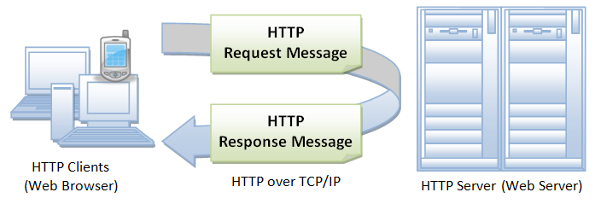

HTTP is an application layer protocol. A web browser is a client/customer to HTTP sending out solicitations to the server machines. When a user opens a web document by entering the URL (Uniform Resource Locator) by tapping the hypertext Interface. The program is designed in such a way that the HTTP request is directed to the IP address redirected by the URL.

**HTTP is classified by 3 main features:**

**HTTP is connectionless:**

The HTTP client, i.e., a browser starts an HTTP request and after a request is made, the client detaches from the server and sits tight for a response. The server forms the request and re-builds up the connection with the client to send a response back.

**HTTP is media neutral:**

It implies, any sort of information can be sent by HTTP the length of both the client, what's more, the server know how to deal with the information content. It is required for the client and also the server to determine the proper content type utilizing proper MIME-sort.

**HTTP is stateless:**

As specified above, HTTP is connectionless, and it is an immediate consequence of HTTP being a stateless convention. The server and client know about each other just amid a present request. Thereafter, the two disregards each other. Because of this nature of the convention, not one or the other the client nor the browser can hold data between various requests over the web pages.

**Http Server:**

A Http server serves information to the clients using the HTTP protocol. It is called as the “web server” which holds the records for HTML reports, pictures, CSS, templates and JavaScript records and conveys them to the client. A http server presents as a single server virtually but is a collection of multiple servers. On the software side of a HTTP server, it incorporates the control mechanism on how the HTTP clients receive the documents sent by a server. It comprehends the URL’s with the URI (Uniform resource Identifier) and the convention of the HTTP programming where we get to see the web pages.

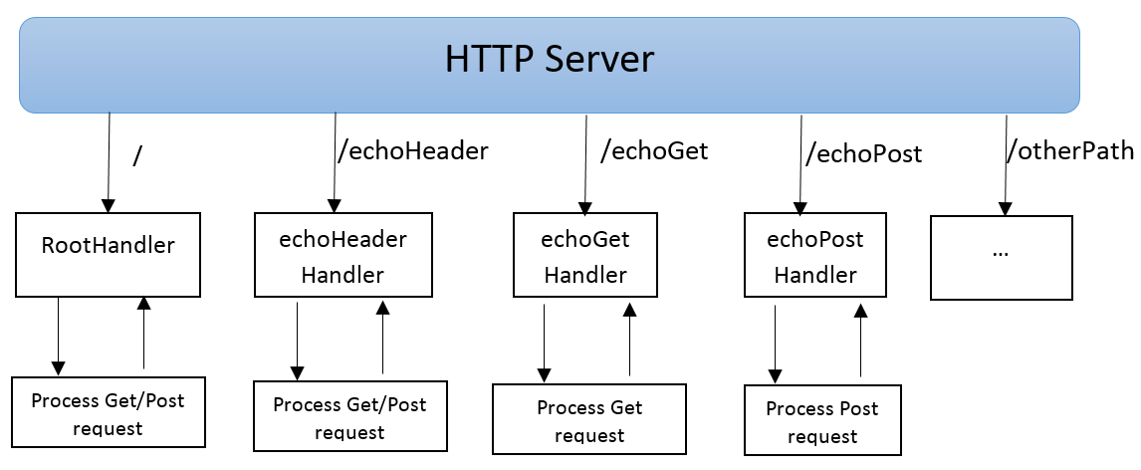

**HTTP Request:**

HTTP Request is the primary message that is sent from the client-side to the server-side after establishing a successful connection between both the entities. The Request method consists of the following fields:

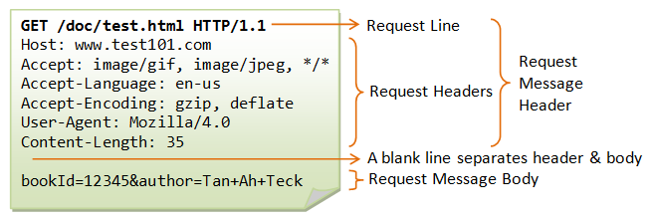

1. An opening line which constitutes the method, requested server resource and the HTTP version also known as the request-line.
2. Multiple header Lines such as general-header, request-header, entity-header
3. A blank line
4. Message Body

The Request-Line is represented as follows:



The **method** of the request-line indicates the type of method to be performed. Identified by the URI. Some of the methods are:

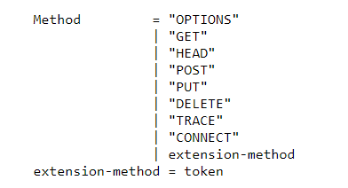

The **Http request methods** are explained as below:

1. **OPTIONS**: It knows the list communication methods supported by the server
2. **GET**: It is used to get a web resource from the server to the client.
3. **HEAD**: It gets the valid header upon the GET request.
4. **POST**: It posts the data to the web-server
5. **PUT**: It informs the server to store the data.
6. **DELETE**: It deletes the data stored in the server.
7. **TRACE**: It is used to perform the loop back test on the messages along the path to the server.
8. **CONNECT**: It is used to establish a TCP/IP tunnel to the server.

The **Request-URI** is an identifier that identifies the resource that should be sent in reply to the request.



The absolute URI is the form that requires the request that is made is a proxy and it is forwarded to claim the service from a valid cache and return a valid response. A proxy is an entity in which it should be capable of recognizing its server names, aliases, and the IP addresses. A request-Line looks like below:



The **authority** in the Request-URI is used by the CONNECT method and the Request -URI is basically used to identify a document or a resource on a server in order to send the reply to the client.

The **Request Header** fields can pass the additional information issued by the client about the request or the information of the client and they can be extended in combination of the protocol version change and the entities in the communication should identify the request-header fields. The unidentified header fields are treated as **entity header** fields.

The Request-header types are as follows:

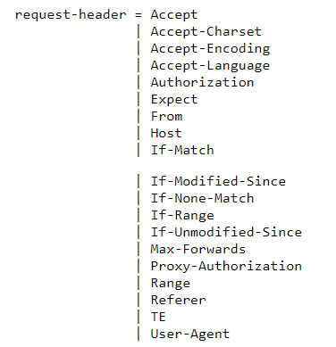

**Http Response:**

In Response to the HTTP request, the server issues a HTTP response in which it returns the HTTP version, status code, and a brief explanation as a reason phrase. The Response headers are usually represented in the form of value sets. The response message body constitutes the data and resources requested by the client.

The nature of the status code can be predicted by observing the first digit of the status code.

1. 1xx - Information

2. 2xx - Success

3. 3xx - Redirected

4. 4xx - Client error

5. 5xx - Server error

The HTTP response codes are demonstrated as below:

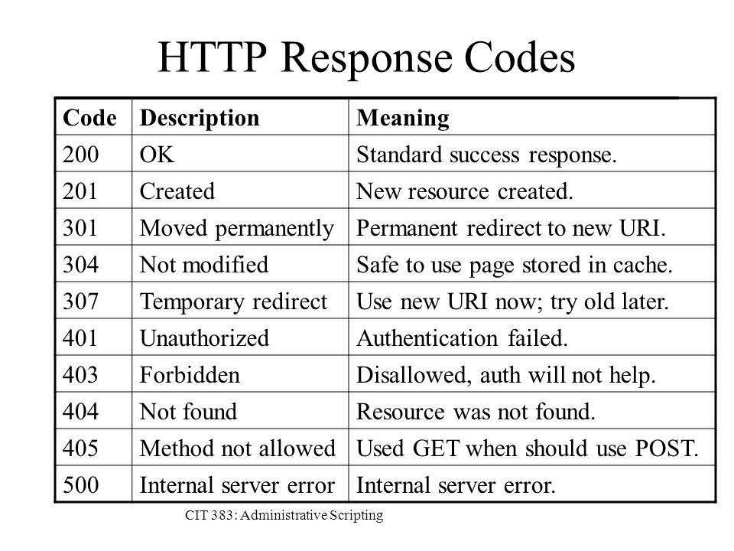

*Image: Http response codes*

**Lab Setup:**

1. Connect the system to Internet.

2. Open shell and use telnet to establish connection to a server.

3. Use different HTTP methods and start capturing data packets using Wireshark.

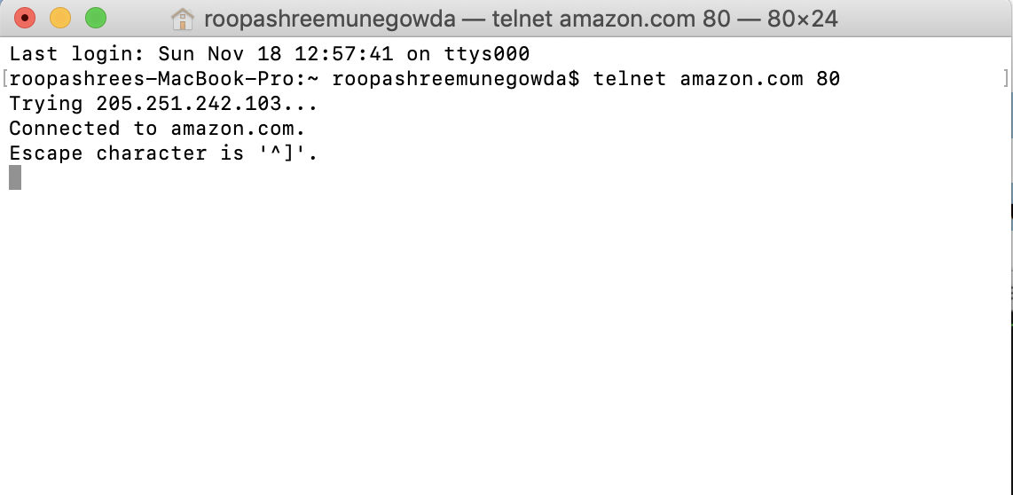

**HTTP GET:**

GET is used to retrieve data from the target server. This message is harmless in way that it can be executed repeatedly. These requests can be cached, and they remain in the browser history. We can also bookmark a GET request. It is not advisable to use HTTP GET while dealing with sensitive data. GET requests have length restrictions.

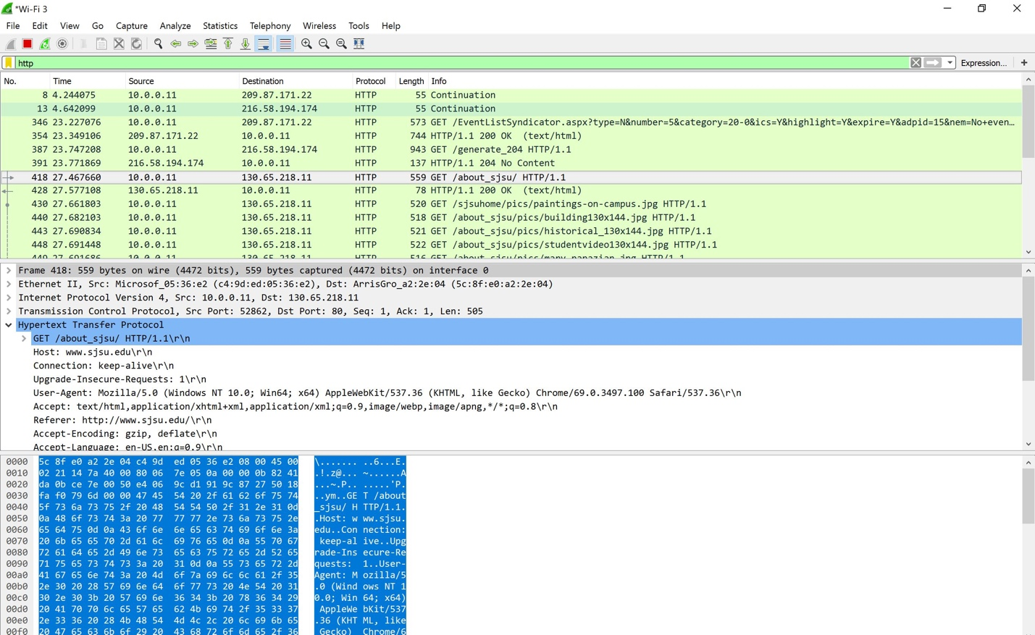

**HTTP POST:**

The POST method is used to request that the origin server accept the entity enclosed in the request as a new subordinate of the resource identified by the Request-URI in the Request-Line. The actual function performed by the POST method is determined by the server and is usually dependent on the Request-URI. The posted entity is subordinate to that URI in the same way that a file is subordinate to a directory containing it, a news article is subordinate to a newsgroup to which it is posted, or a record is subordinate to a database.

The action performed by the POST method might not result in a resource that can be identified by a URI. In this case, either 200 (OK) or 204 (No Content) is the appropriate response status, depending on whether or not the response includes an entity that describes the result.



**HTTP 200 OK:**

Indicates that the request has been was successfully granted. The payload sent in a 200 response depends on the request method. For the methods defined by this specification. Aside from responses to CONNECT, a 200 response always has a payload, though an origin server MAY generate a payload body of zero length. If no payload is desired, an origin server ought to send 204 no content instead.

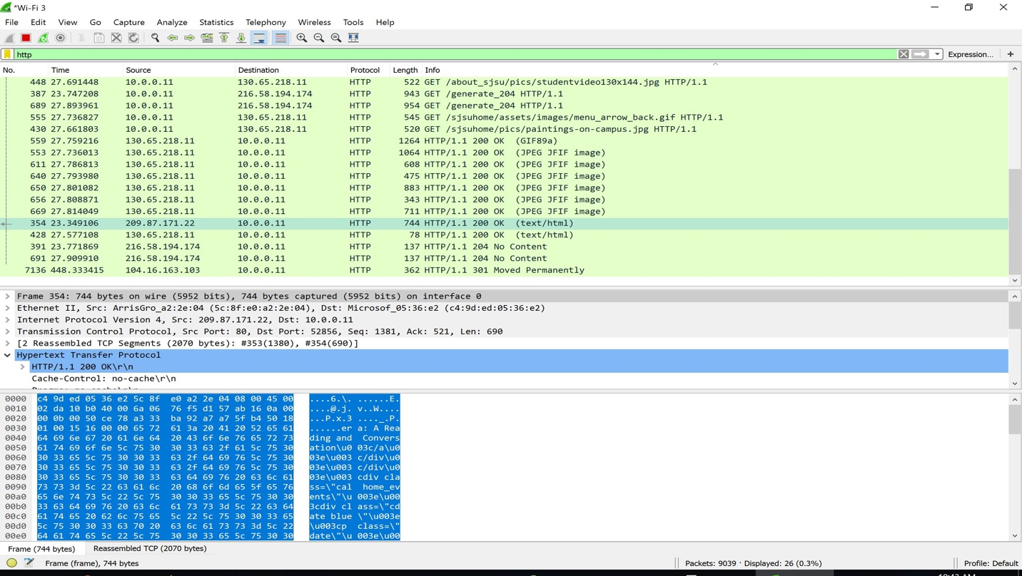

**HTTP 301 MOVED PERMANENTLY:**

The target resource has been assigned a new permanent URI and any future references to this resource ought to use one of the enclosed URIs. Clients with link-editing capabilities ought to automatically re-link references to the effective request URI to one or more of the new references sent by the server.

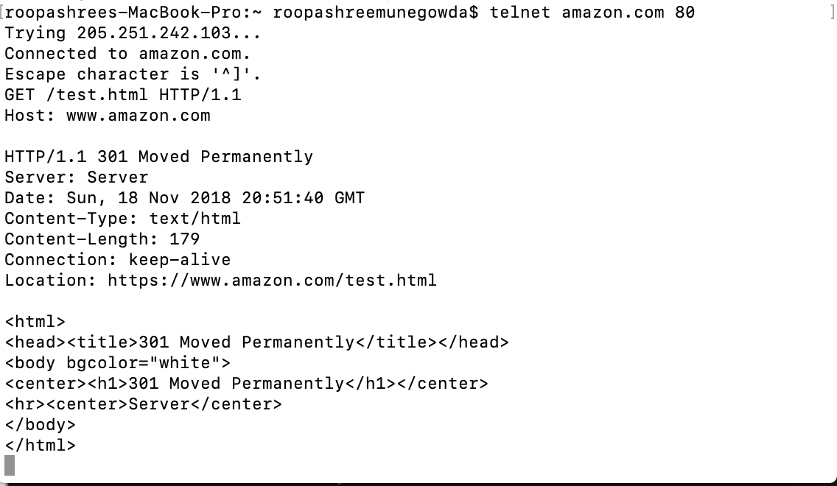

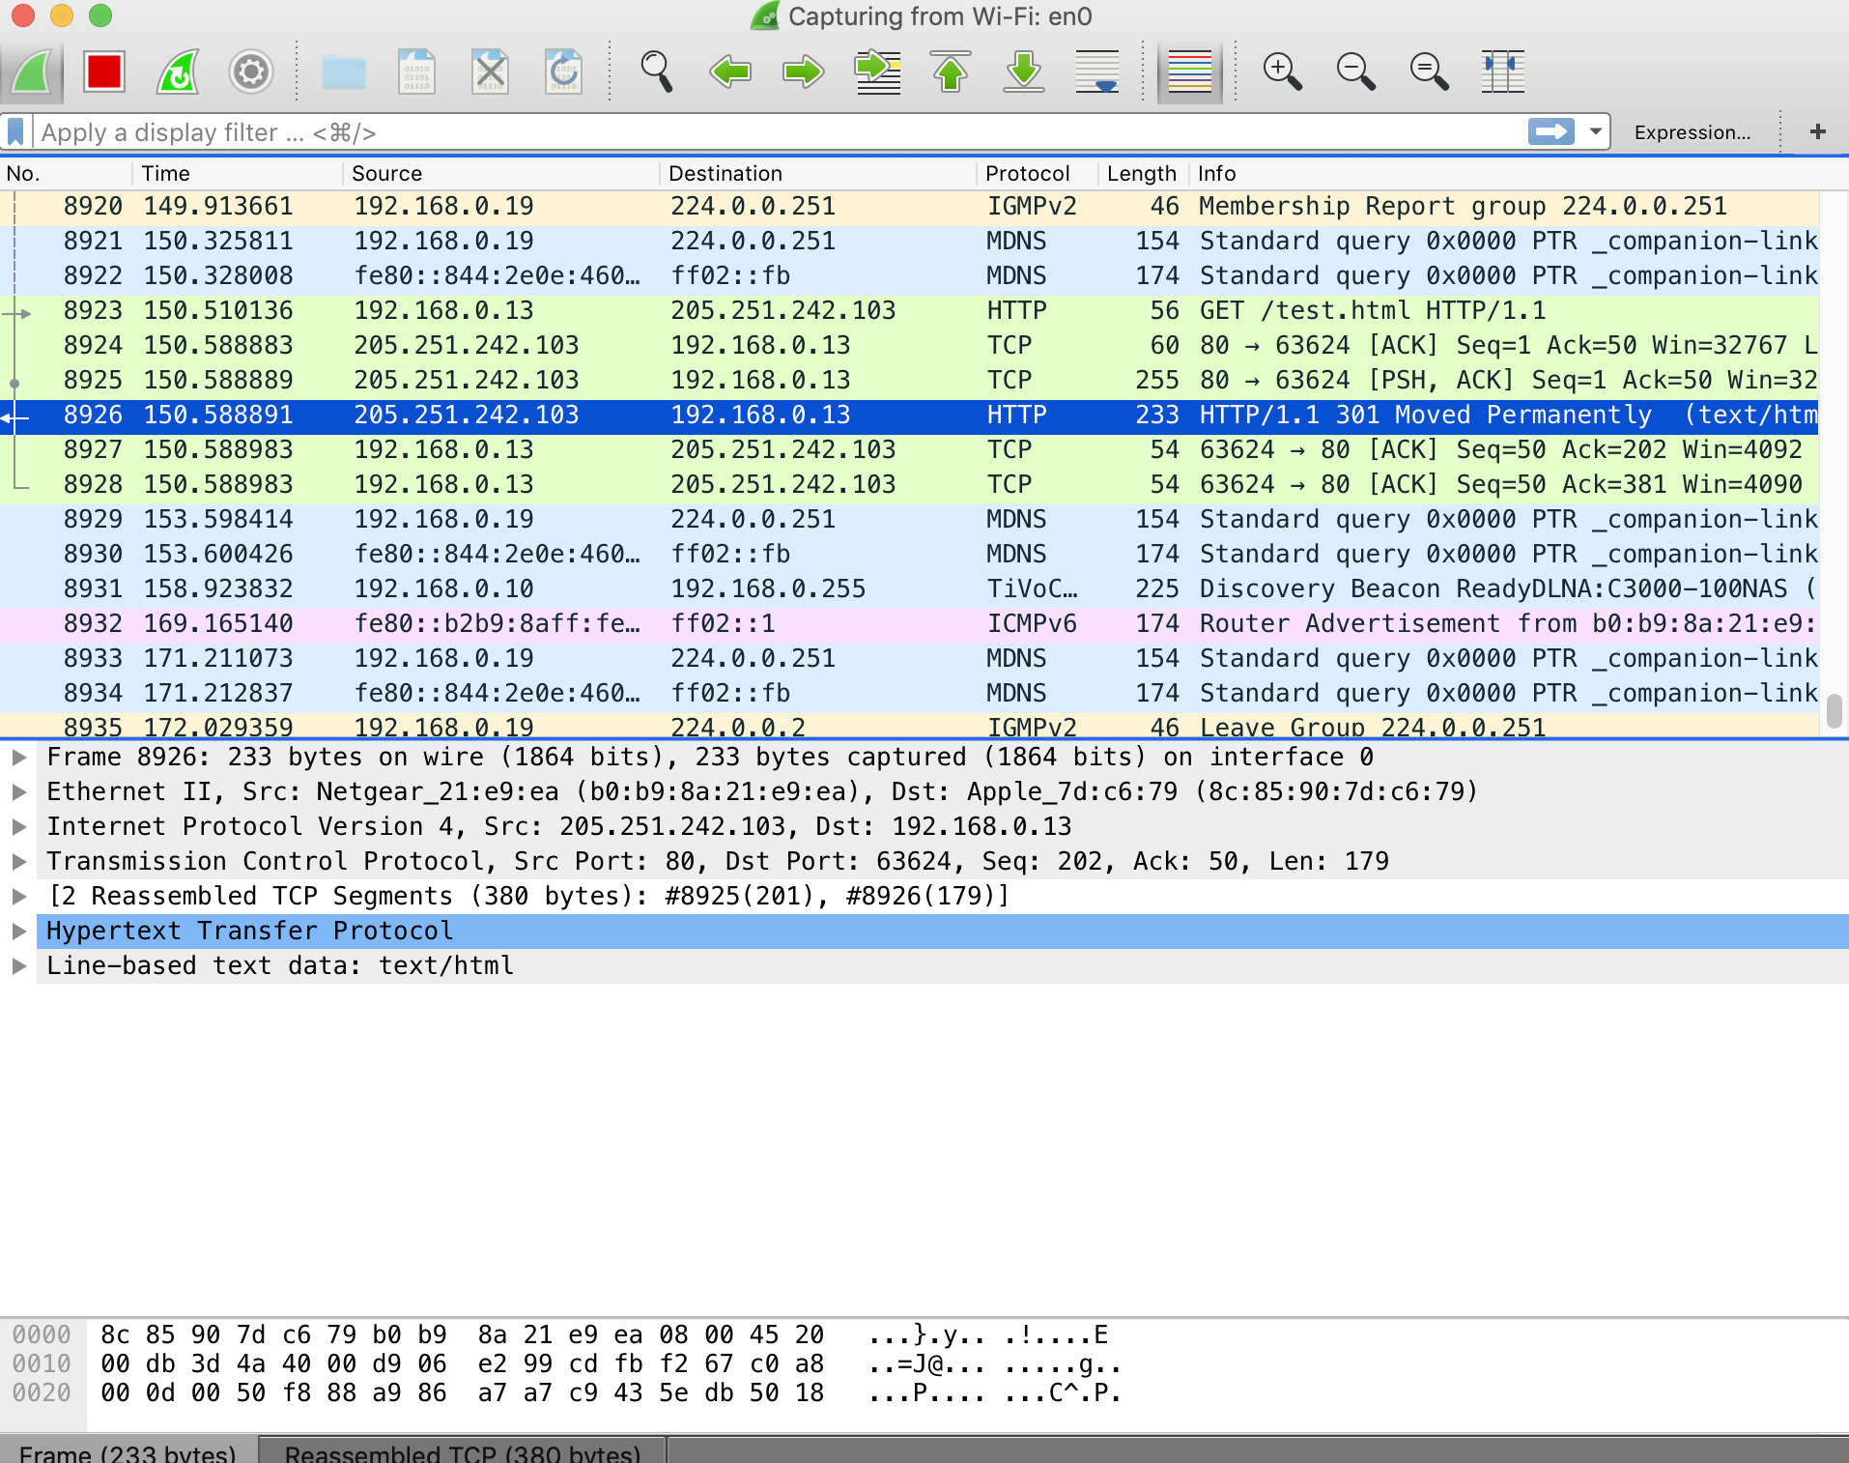

**HTTP 404:**

The origin server did not find a current representation for the target resource or is not willing to

disclose that one exists. A 404 status code does not indicate whether this lack of representation is

temporary or permanent; the 410 Gone status code is preferred over 404 if the origin server knows,

presumably through some configurable means, that the condition is likely to be permanent.



**HTTP 503:**

The server is currently unable to handle the request due to a temporary overload or scheduled maintenance, which will likely be alleviated after some delay. The server MAY send a Retry-After header field1 to suggest an appropriate amount of time for the client to wait before retrying the request.



**Conclusion:**

Based on the gathered information we can say HTTP protocol is widely used over the internet framework to perform important operations. The different methods and their implementations had been studied. HTTP protocol is a connectionless layer seven protocol which operates over underlying protocol layers. The working of HTTP is reminiscent to TCP. We also analyzed and studied the HTTP message structure.

**References:**

• https://en.wikipedia.org/wiki/Hypertext_Transfer_Protocol

• Computer Networks by ANDREW S. TANENBAUM and David J. Wetherall

• https://tools.ietf.org/html/rfc2616

• https://developer.mozilla.org/en-US/docs/Web/HTTP